| **Test Name** | | Voting on Questions –Like a question | | | |
| --- | --- | --- | --- | --- | --- |
| **Use Case Tested:** | | Play a Game | | | |
| **Test Description:** | | To test whether players can vote on questions | | | |
| **Pre-conditions** | | User must of logged in  User must have started a game | | | |
| **Post-conditions** | | That a user can like a question  The database records +1 to the questions upvotes and a rating that is upvotes - downvotes | | | |
| **Notes:** | |  | | | |
| **Result (Pass/Fail/Warning/Incomplete)** | | **Pass** | | | |
|  | **TEST STEP** | | **EXPECTED TEST RESULTS** | P | F |
|  | System displays a question | | The user should see a question, answers and green thumbs up icon and red thumbs down | P |  |
|  | User clicks the green thumbs up icon | | That the icon is clickable | P |  |
|  | System displays a message | | That the user sees the message --- displayed | P |  |

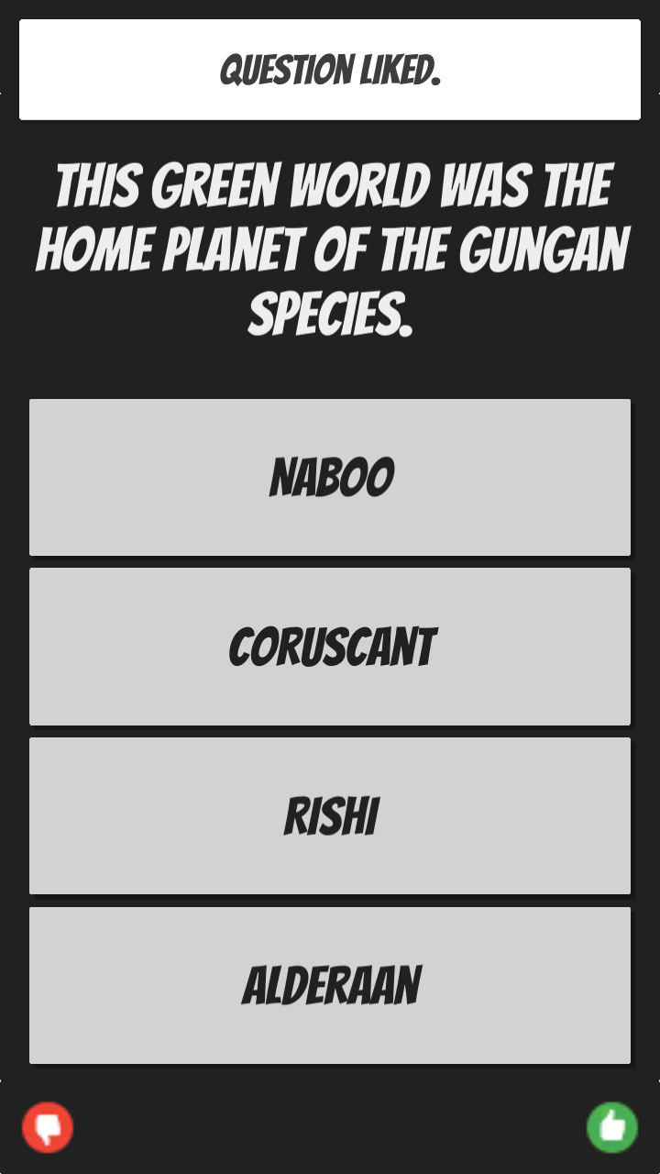

| **Test Name** | | Voting on Questions –Dislike a question | | | |
| --- | --- | --- | --- | --- | --- |
| **Use Case Tested:** | | Play a Game | | | |
| **Test Description:** | | To test whether players can vote on questions | | | |
| **Pre-conditions** | | User must of logged in  User must have started a game | | | |
| **Post-conditions** | | That a user can dislike a question | | | |
| **Notes:** | |  | | | |
| **Result (Pass/Fail/Warning/Incomplete)** | | **Pass** | | | |
|  | **TEST STEP** | | **EXPECTED TEST RESULTS** | P | F |
| 1. | System displays a question | | The user should see a question, answers and green thumbs up icon and red thumbs down | P |  |
| 2. | User clicks the red thumbs down icon | | That the icon is clickable | P |  |
| 3. | System displays a message | | That the user sees the message --- displayed | P |  |



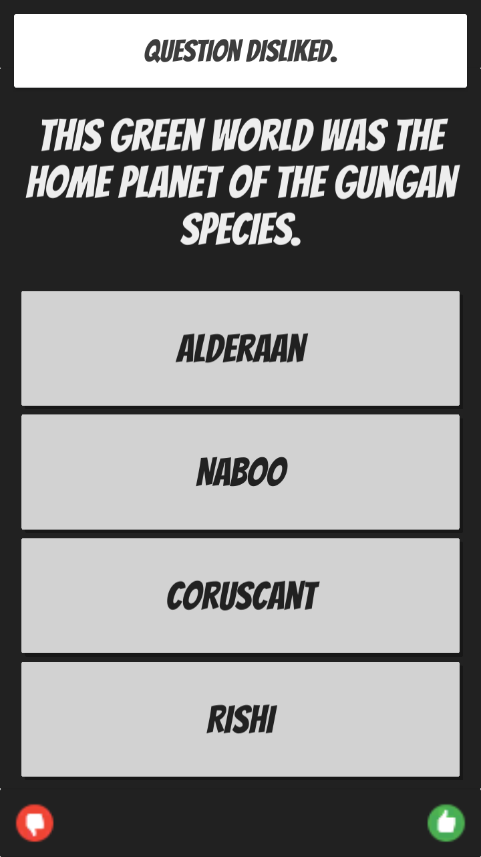

| **Test Name** | | Display Voting Leader Board | | | |
| --- | --- | --- | --- | --- | --- |
| **Use Case Tested:** | | Voting | | | |
| **Test Description:** | | To test that the UI displays voting leader board | | | |
| **Pre-conditions** | | Application needs to be open | | | |
| **Post-conditions** | | Leader board will be displayed to user | | | |
| **Notes:** | |  | | | |
| **Result (Pass/Fail/Warning/Incomplete)** | |  | | | |
|  | **TEST STEP** | | **EXPECTED TEST RESULTS** | P | F |
| 1 | User logs in and opens main menu | | Main menu is displayed | P |  |
| 2 | User presses Leader board | | Leader board should be displayed | P |  |
| 3 | User press the ‘Top Question’ button | | The top question leader board is displayed | P |  |

